**National University of Computer & Emerging Sciences**

**Karachi Campus**



**Project Report**

**Programming Fundamentals**

**Section: I**

**Group Members:**

**18k-1148 Uzair Ali**

**18k-0200 Muhammad Usama**

**Introduction**

We have developed a scientific Calculator that is also capable of plotting graphs from a given polynomial equation.

* **Existing System**

We have seen many scientific calculator like the one which is in our study bag. This idea of building scientific came from that calculator that we use.

* **Problem Statement**

We have seen many scientific calculators but none of them was capable of solving equations and plot a graph from that equation.

* **Proposed Solution**

We are designing a calculator which can perform all scientific operations plus it will plot graphs from a given equation

* **Salient Features**
* **Applications Of Graph Plotting**

1. Our program can recognize the plane of the graph by lighting up the quadrant in which the point we entered lies.
2. By entering any two points we can find out the midpoint and can represent it on a graph.
3. Verification of points on graph if the distance and a point is entered in our program.
4. our program can find out the intersection of the two lines and show us by plotting a graph.
5. We can find out distance between any two points entered by the user. This is also

Represented on graph plane.

1. By entering the coordinates of the centre point and the radius of the circle, Our program can sketch the a circle and show its radius line.
2. By entering the values of axis (h,k)&a ..here (h.k) represent the axis of parabola and ‘a’ represents focus of parabola our program can plot parabola on the plane.
3. By entering the values of axis (h,k)&a ( (h.k) represent the axis of hyperbola and ‘c’ represents focus of hyperbola and ‘a’ represents major axis whereas ‘b’ represents minor axis of hyperbola) our program can plot hyperbola based on the values mentioned above.

* **Applications Of Scientific Calculator**

1. This program consists of all the functions that a hand held scientific calculator possesses

* **Tools & Technologies**

Programming language used is C

Operating system used is windows 10 64 bit

Turboc++ is used as our compiler

# PHOTO GALLERY

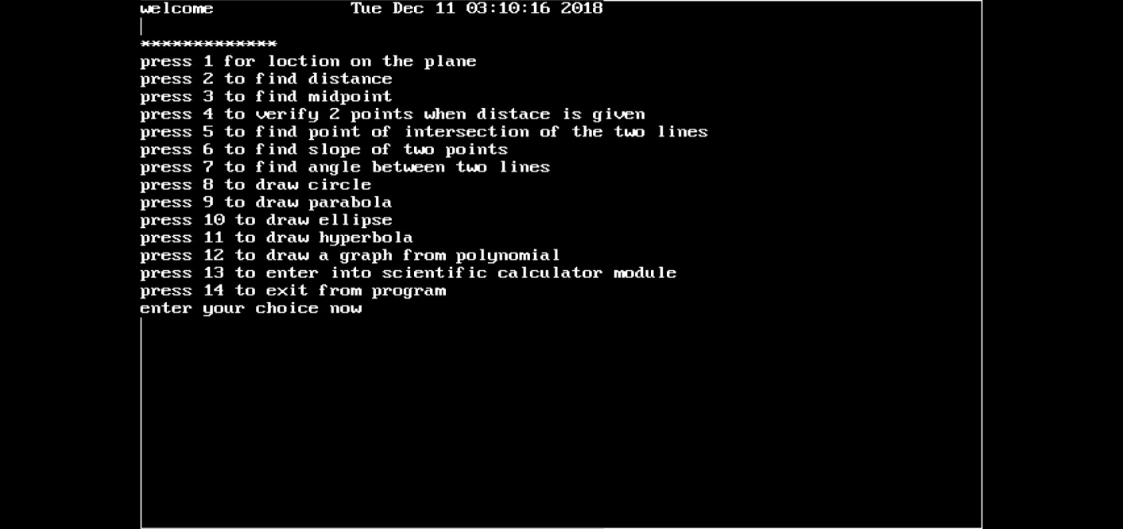1 MAIN MENUE

2 SCIENTIFIC CALCULATOR MENUE

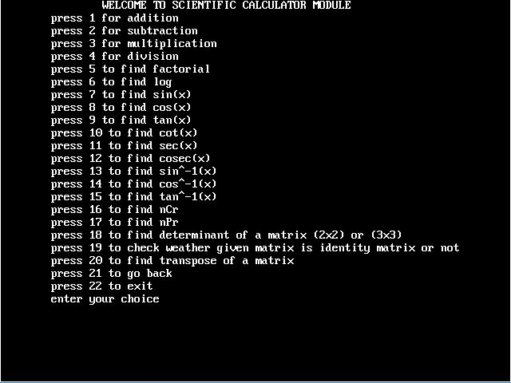

3 PARABOLAS

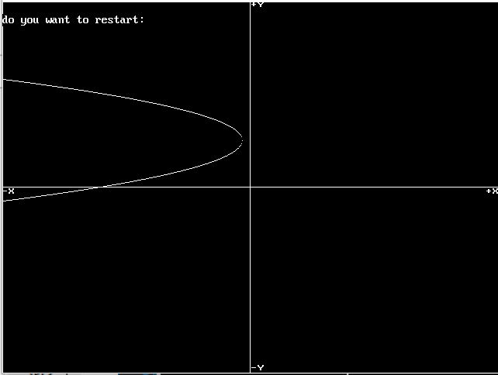

4 HYPERBOLAS

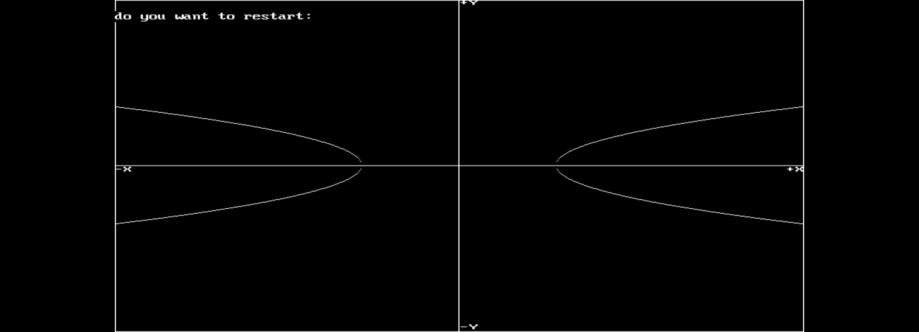

5 CIRCLE

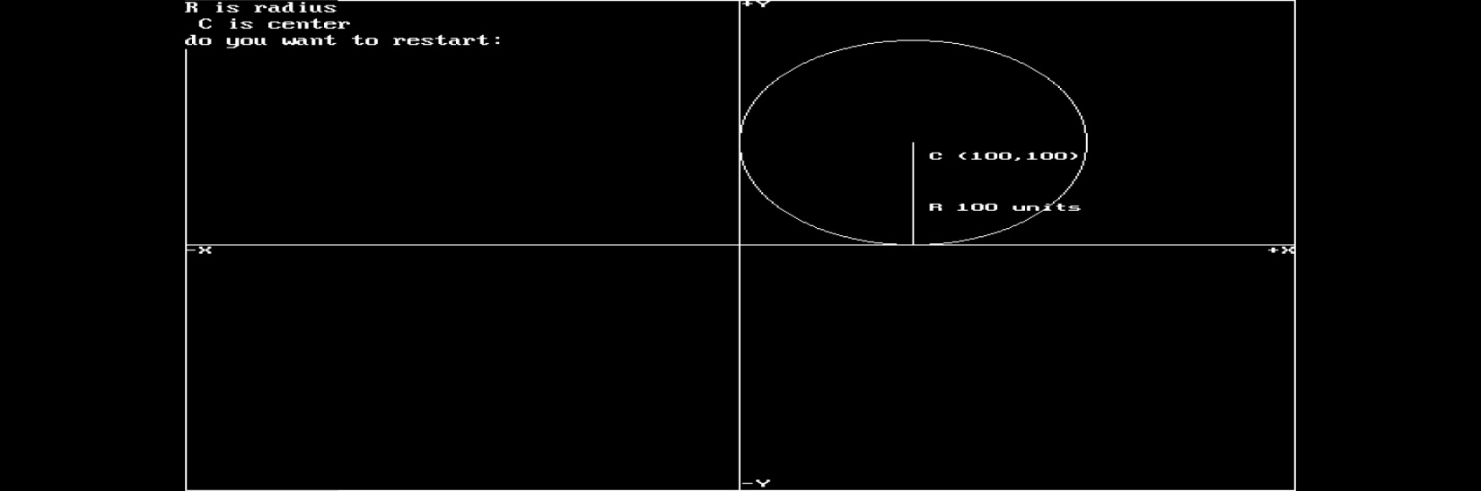

6 DISTANCE BETWEEN TWO POINTS

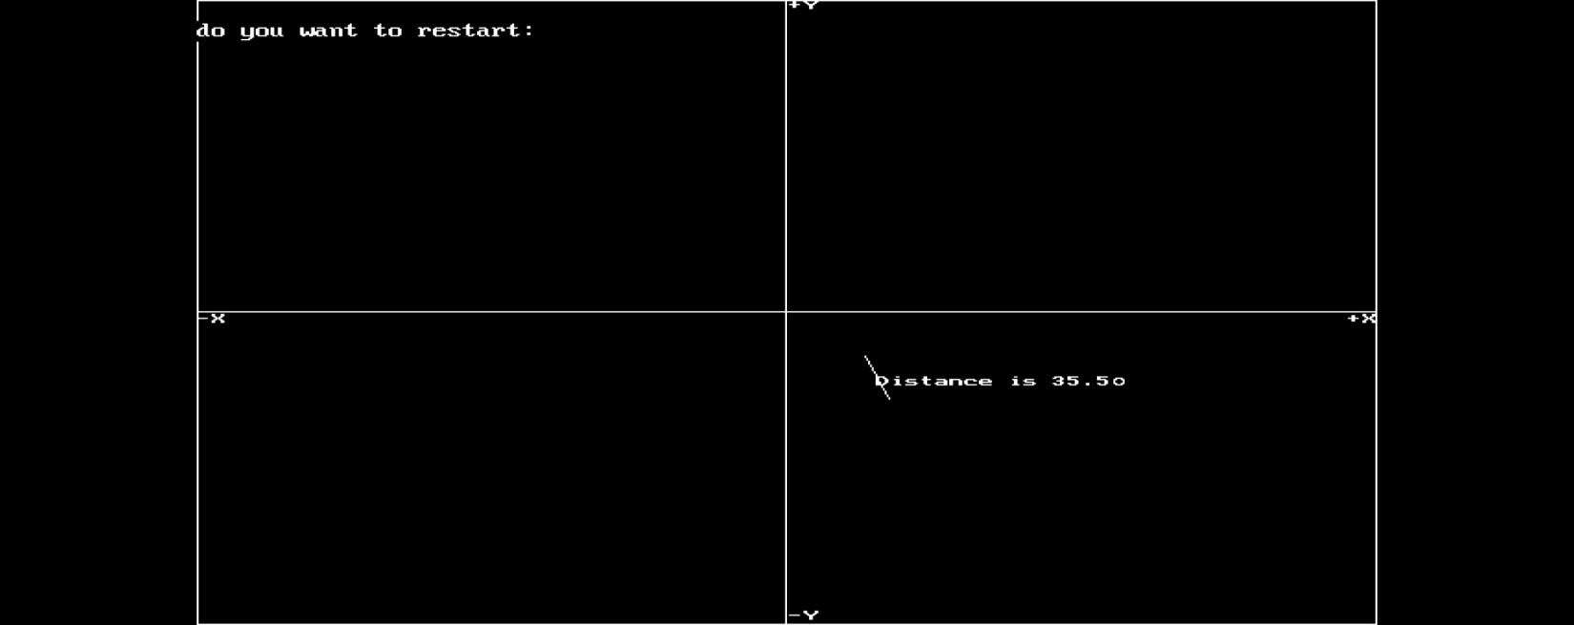

7 SLOPE

